*F&F STUDY GROUP*

By

Farrukh Makhkamov U1610068 (003)

Farrukhjon Akramov U1610070 (001)

https://github.com/iuthub/design-project-f-f.git

**Internet Programming**

Pr. Sarvar Abdullaev

# Introduction

Our project named “F&F Study Group” is our start up idea. The topic we have chosen is online test. We started preparing this site approximately 3 months ago; we are still working on it. Project is created for e-learning. (Login and passwords are at the end of the report)

# Look and feel

First you entered the web site you can easily get some information about the company. In main page we have put Bootstrap 3 slide carousel which automatically runs 3 different types of information images about new courses.

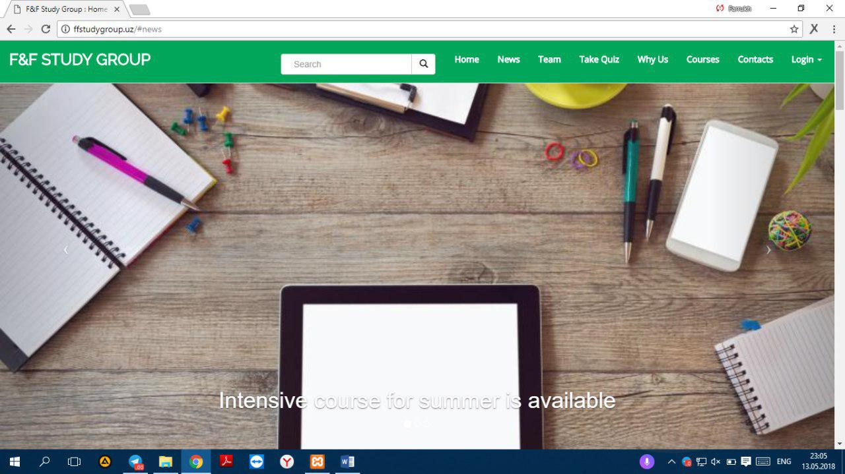

On the top of web page you can find our bootstrap navigation bar, which property is set on static top, which makes it move freely through all web page. Here we have all our main functionalities of web page, using navigation bar you can learn about us, our team, take quiz and login or sing up.

You can enter as a admin and authorizedas a simple user. After logged in as student you automatically go to page where you will be asked to take quiz or just know your result to quiz you have already got. Here we have two types of quiz – english and math so far. Each course has its level elementary, intermediate and advanced, admin can extent them as mush as he/she wants.

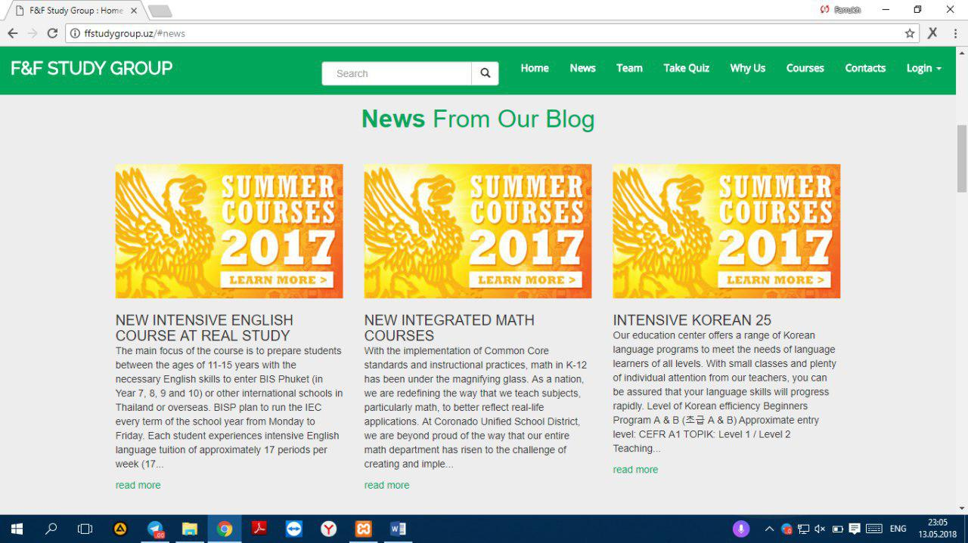

In the news part, all news are taken from database, which makes it quite dynamic.

As adminstrator simple adds heading, body and an image

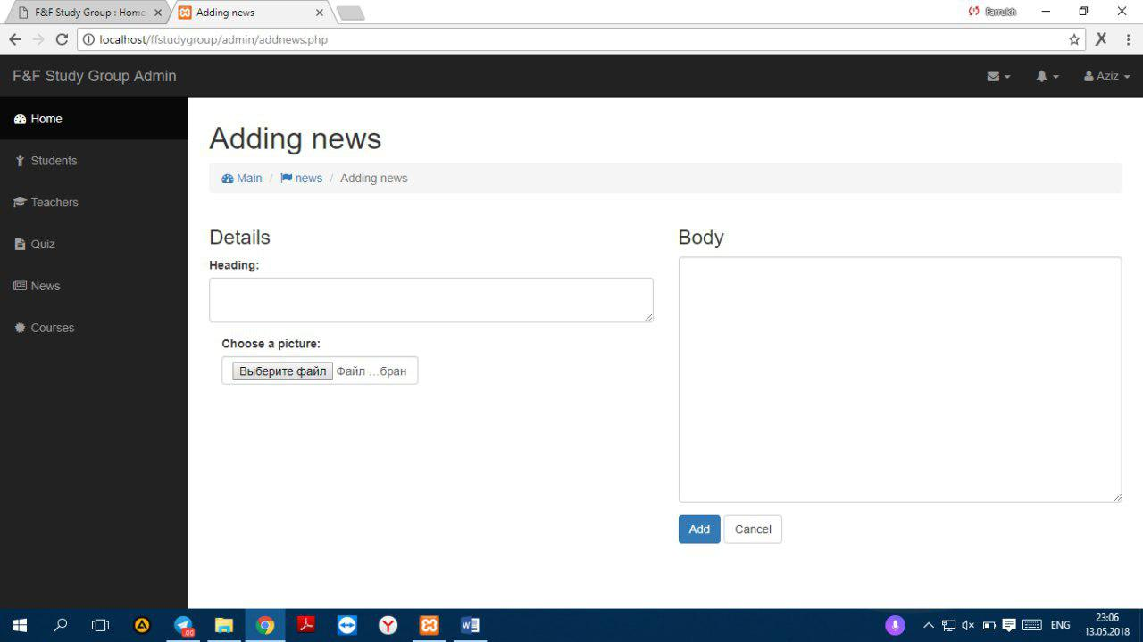

At the bottom of each news there is ‘read more’ feature, when it is pressed it automatically takes you the website’s full news page.

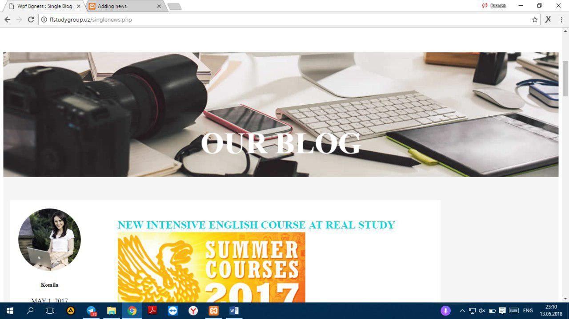

Here, users can read all the news, which are recent, and most popular.

In WHY US part simple attracts students why students should choose the education center.

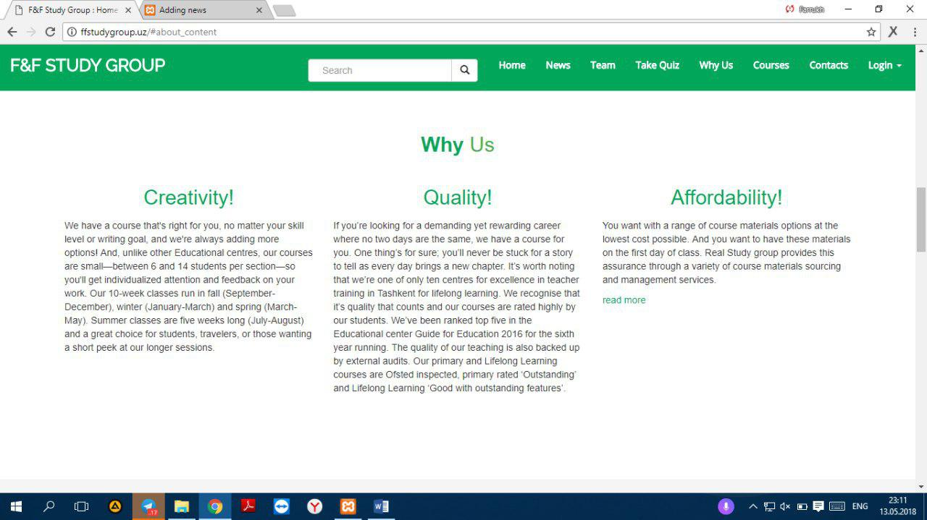

In courses part, there are a couple of most popular courses,

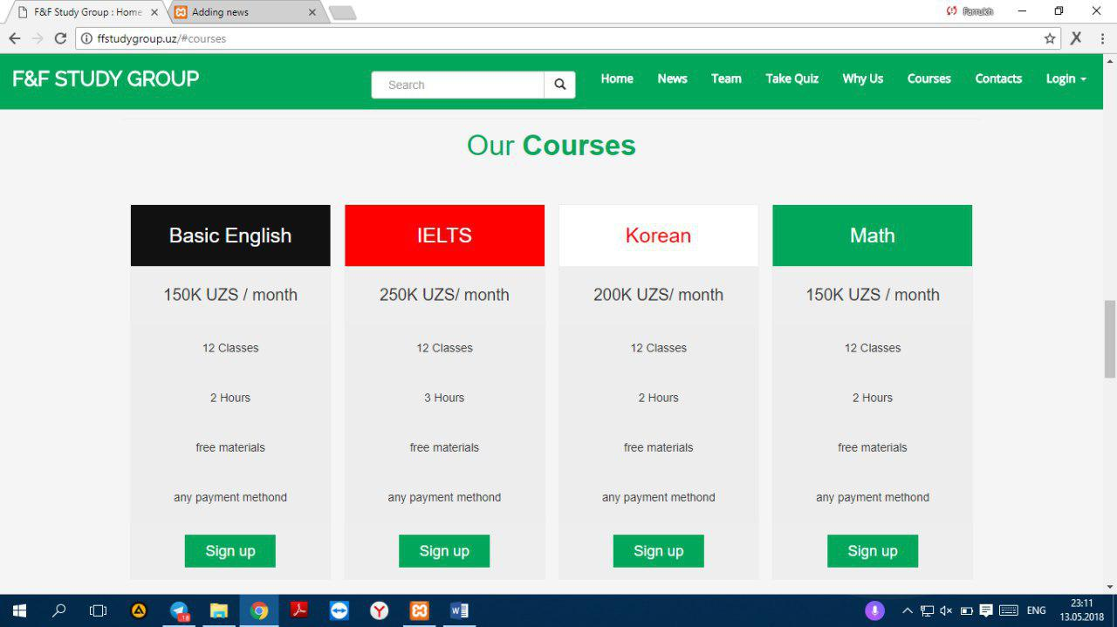

Users can read all necessary information about these courses, and can simple register any of these courses that she or he wants

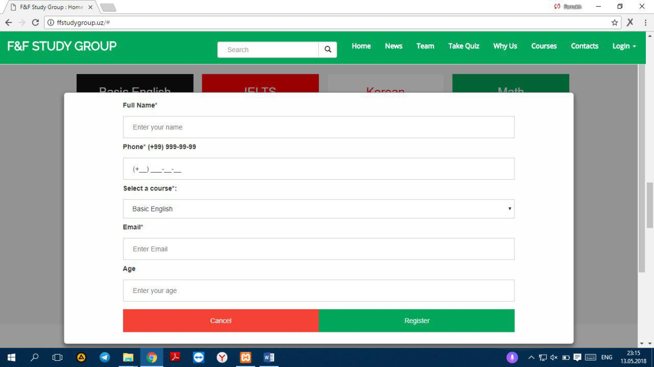

Also there is **data validation** in entering phone number. To do this we created our own **Jquery** input mask function. It takes only desired number of numbers.

In the CONTACT part, user can find out our location via Google map, and see, like and follow the F&F study group’s facebook page. Additionally, user may send a message to admin

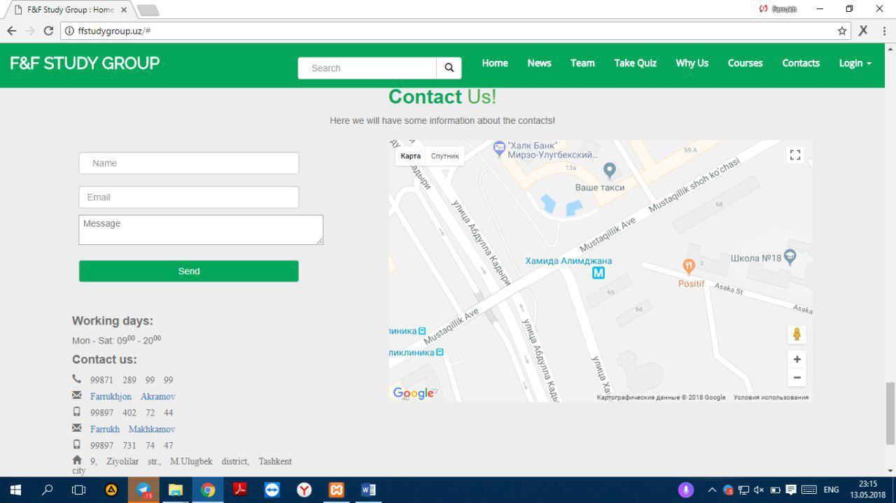

When a user sends massage, it automatically appears admin massages page.

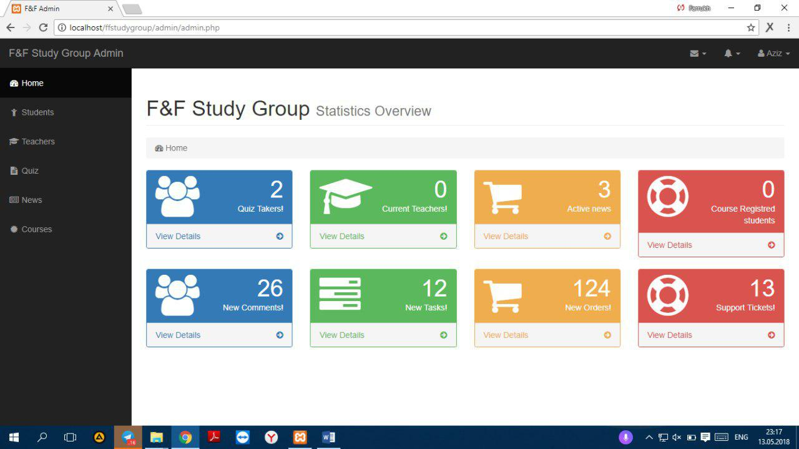

Admin can also read all massages from read all massages button on top of the massages.

## Take a quiz part!!!!

One of the super cool feature our website where users can take quizzes,

In order to take quiz every users must have been registered

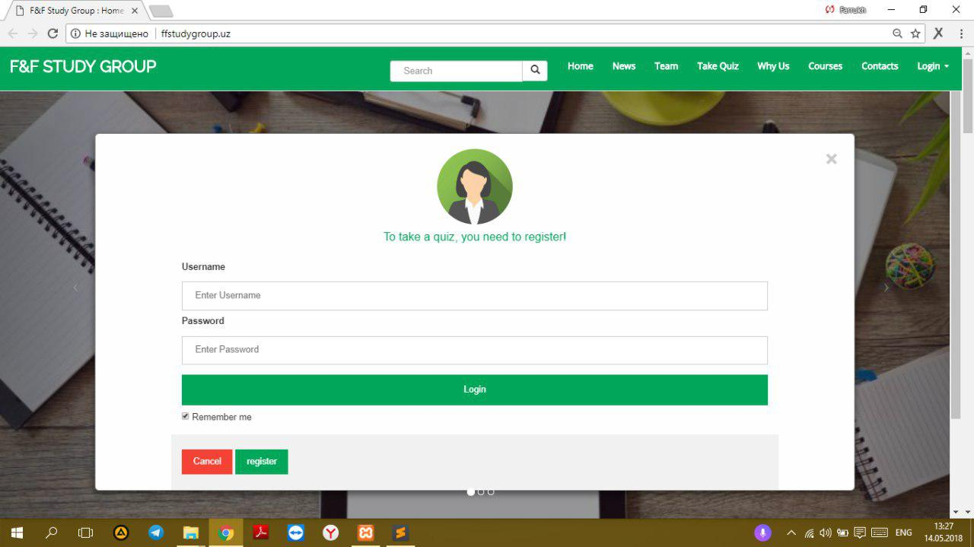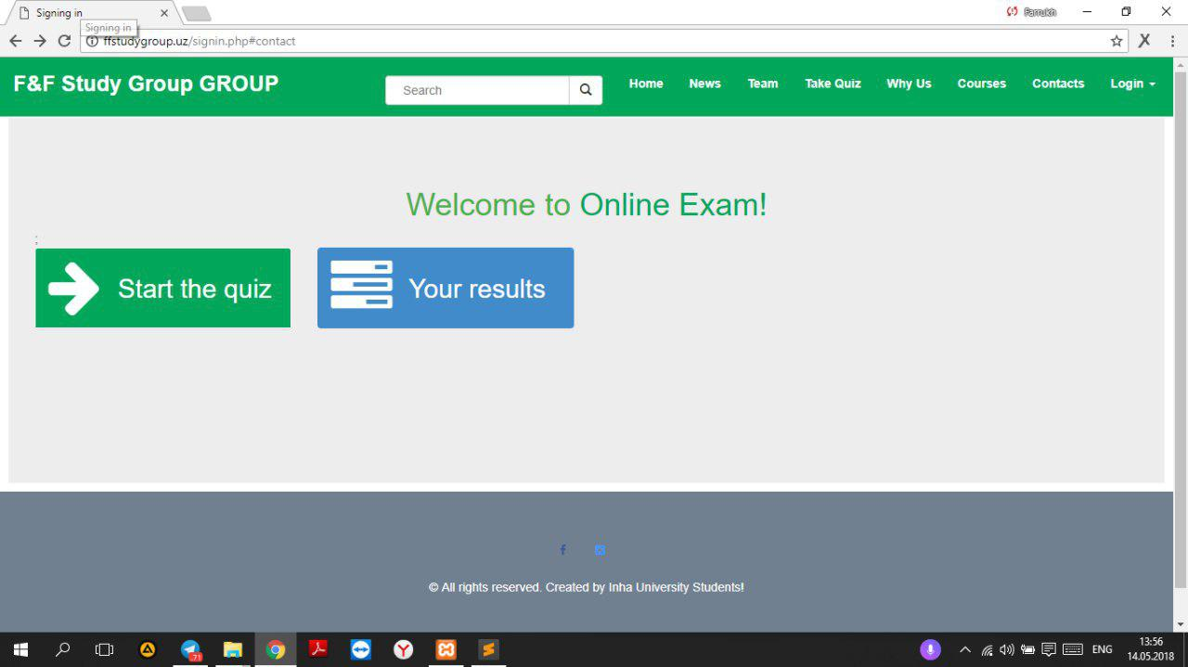

They can choose variety subjects to give a quiz, and also they can check their results.

After finishing the quiz, quiz taker can review the questions.

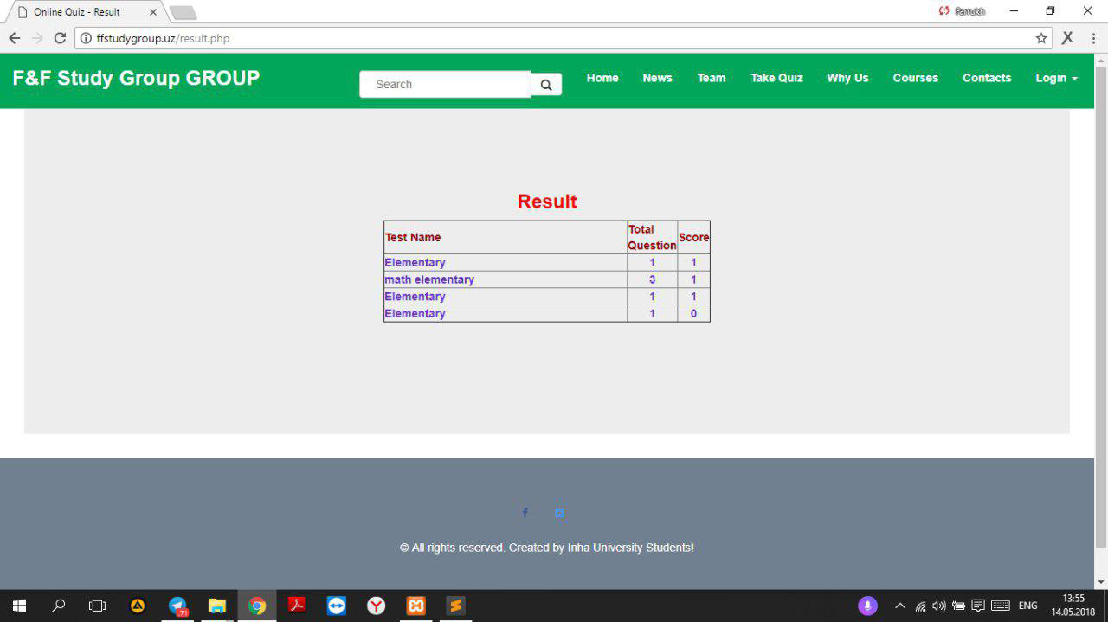

### Admin

When it comes to talking about what properties the administrator has. After you logged in as admin you go to our dashboard and there we have main page and sidebar menu.

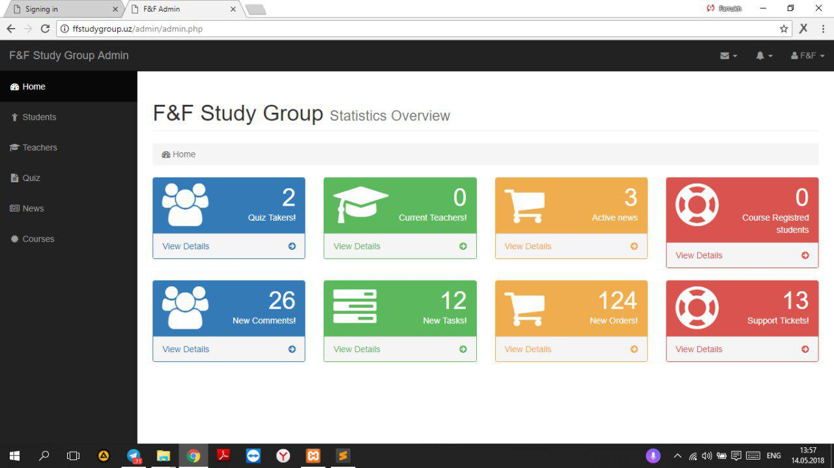

Here we have detailed information about taken quizzes, current teachers and students, number of registered courses, subject to be tested, test for quiz, question for quizzes and messages. Using all of them **our admin can easily do his work by adding quizzes, answering to messages and give quizzes answers.**

On sidebar menu you can find out 5 main sub pages. There are “Students”, “Teacher”, “Quiz”, “News” and “Courses”. After going to student you can add new student and get appropriate information about already registered student. In “Teachers” you can do the same action but dealing with teachers. In “Quiz” you can add new quiz, manage the content of quizzes and check taken quizzes. In “News” we mostly work with news on page “Our Blog” and can add new information and manage the old ones.

Technical sides

If we talk about technical sides of web site we should say that site is totally responsive and could freely be opened in any device whether it is PC, tablet or smart phone!

PC version

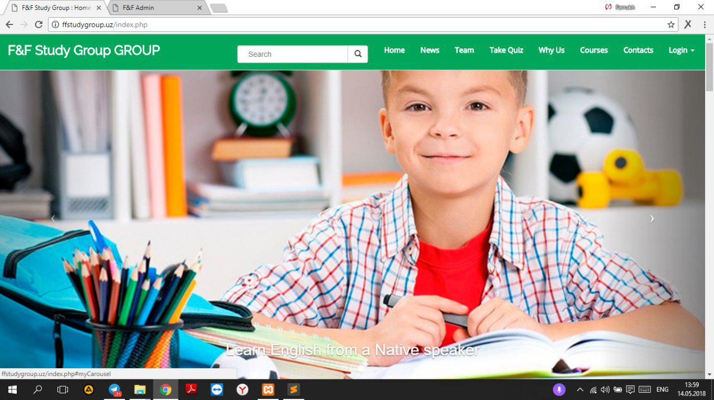

Tablet Version

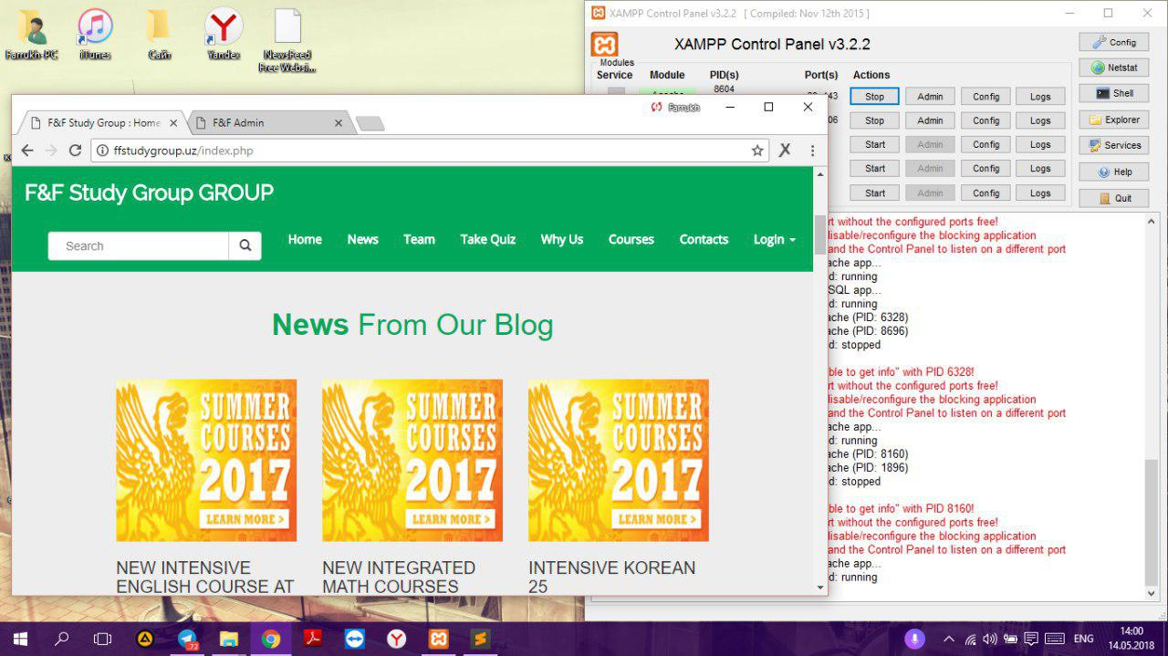

Mobile Version

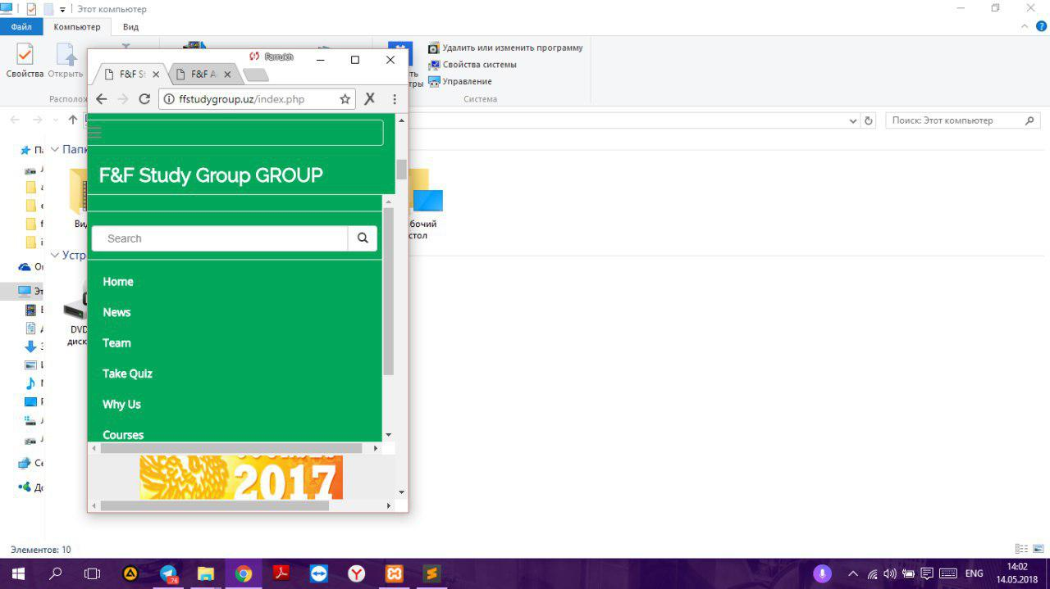

The main advantage of our page we think that it is absolutely responsive and source code was written in such way so every user can easily understand it, because we had left commentaries to our code wherever it is necessary.

**The link for our website:** https://github.com/iuthub/design-project-f-f.git

**Admin-1:**

Login: farrukh

Password: farrukh

**Admin-2:**

Login: farrukhjon

Password: farrukhjon